|  |  |
| --- | --- |
| **Test Progressive Assistants** |  |
| Business Analysis and Application |
| **For 23-2 Generation** |  |
| ***Valid on*** *Odd Semester Year 2023/2024* |  |

1. Peserta TPA tidak diperkenankan untuk:
   1. Mempublikasikan jawaban yang telah dibuat secara sengaja ataupun tidak disengaja.
   2. Membuka dan/atau menyalin jawaban dari buku, video, ataupun peserta lainnya.
   3. Melakukan tindakan yang menyebabkan jawaban dicontek oleh orang lain atau kelompok lain, baik disengaja maupun tidak disengaja.
   4. Melakukan tindakan kecurangan lainnya.
2. Jika peserta TPA dan/atau terbukti melakukan tindakan seperti yang dicantumkan pada butir ke-1, maka nilai TPA yang melakukan kecurangan, baik menyontek atau dicontek, akan dinolkan sesuai dengan peraturan yang berlaku dan akan diberikan sanksi sesuai prosedur yang berlaku.
3. Jawaban yang dapat diterima dan dinilai adalah jawaban yang dikumpulkan sebelum batas waktu yang telah ditentukan.

|  |
| --- |
| Jakarta, 17 Oktober 2023 |
|  |
| **Justine Winata Purwoko** |
| Assistant Development Officer |

|  |  |  |
| --- | --- | --- |
| IndonesiaTimes.com  Jl. Raya Kb. Jeruk No.27, RT.1/RW.9, Kb. Jeruk, Kec. Kb. Jeruk, Kota Jakarta Barat, Daerah Khusus Ibukota Jakarta 11530 |  | VOL. II NO. 32  JAKARTA, WEDNESDAY, SEPTEMBER 7TH, 2023 |

# Revolutionizing Airport Management: Angkasa Pura’s LinKasa at the Forefront of Technological Innovation

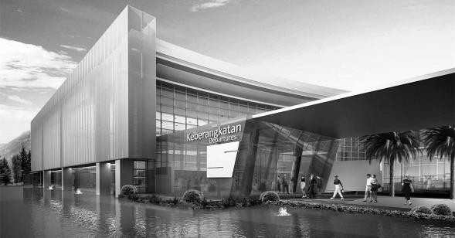*Background:*

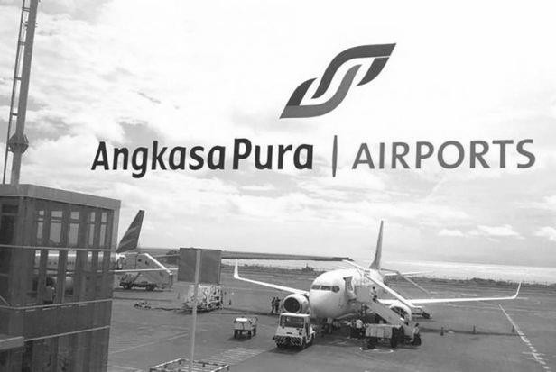In the bustling archipelago of Indonesia, the realm of aviation has always been a vibrant and essential artery of connectivity, fostering economic growth and bridging the intricate lattice of islands that form this vibrant nation. As the steward of Indonesia’s skies, Angkasa Pura has long stood as a beacon of excellence and innovation in the industry. Established with a vision to usher the Indonesian aviation sector into a future marked by technology-driven advancement and sustainable growth, Angkasa Pura has continually adapted to meet the dynamic needs of a burgeoning air travel sector.

In a pivotal move, as the world entered an era marked by an accelerated pace of technological advancement, Angkasa Pura envisioned a quantum leap that would redefine the traditional paradigms of airport management. Thus, in the hallowed halls of its innovation lab, the seeds of **LinKasa** were sown. A brainchild of a dedicated team of visionaries, engineers, and industry experts who foresaw the convergence of technology and aviation as a golden opportunity to elevate the airport ecosystem to unparalleled heights.

*Main Story:*

In a landscape where technological advancements are imperative, the aviation sector and notably, Angkasa Pura, has not lagged behind in embracing innovation. Rising to the occasion, Angkasa Pura pioneered the creation of **LinKasa**, a groundbreaking desktop application designed to transform the complex ecosystem of airport management into a streamlined, cohesive operation.

Encompassing several pivotal units including executive, operations and coordination, safety and security, and logistics, among others, Angkasa Pura discerned the necessity of a system that would amalgamate the diverse facets of airport management into a unified platform. **LinKasa** was conceptualized to fulfill this need, fostering seamless communication and coordination across all divisions.

The application promises to revolutionize the safety protocols by integrating real-time monitoring and streamlined procedures, setting a new benchmark in customer service by leveraging technology to enhance passenger experience, and revamping the commercial landscape within airports by offering immersive retail experiences. Moreover, it aims to simplify the complexities of logistics, transforming it into a well-oiled mechanism augmenting the economic viability of airport operations.

**LinKasa**, therefore, epitomizes Angkasa Pura’s innovative spirit, offering a user-friendly and customizable tool that harmonizes various technological functionalities to adeptly navigate the intricacies of flight operations and logistical challenges. As depicted in the project document, **LinKasa** is set to be a pivotal ally in ushering a new era of safety and efficiency in airport management, representing Angkasa Pura’s relentless pursuit of excellence and commitment to a future where airport operations are a symphony of seamless tasks, orchestrated with the finesse of modern technology.

# Soal

*Case*

**LinKasa**

This document describes the requirements of **LinKasa** desktop application, an innovative

application designed to streamline and optimize airport management systems. The application encompasses a wide range of features, including scheduling, monitoring, traffic control, and more, that are crucial to the smooth operation of modern airports. **LinKasa** aims to facilitate the complex tasks associated with managing flight operations, ground support, and other logistical challenges. This comprehensive solution is designed to be user-friendly and customizable, providing the essential tools that airport operators need to ensure safety and efficiency.

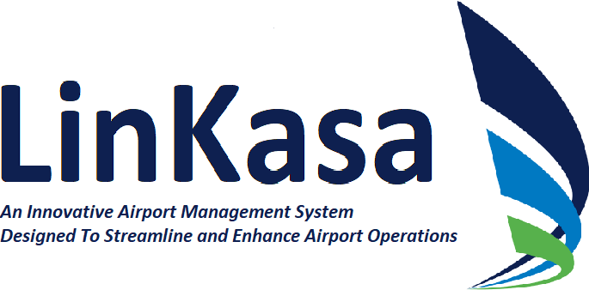

***Figure 1. LinKasa Logo***

To improve airport business management, LinKasa’s managers asked you to develop a system to help them manage the business activity. The complete business details of **LinKasa** are stated below:

**Note:**

The requirements described in this document may change as needed (If any changes were to be made, it will be announced). The purpose of this document is to provide a detailed overview of the functionalities, system requirements, and other essential aspects of the **LinKasa** desktop application. The images that are present in this document are only for explanation purposes only and following it is just optional. Hence, if any problem were to be found in the description or any unclear description is found, please contact casemaker, **Marvin Luckianto (LK22-2)** to ask for clarification.

**Customer Service and Passenger Assistance**

## UNGU ARTINYA KOMUNIKASI ANTAR DEPARTMENT DENGAN DEPARTMENT

## BIRU ARTINYA KOMUNIKASI VIA CHAT FEATURE YANG BISA DILIAT SEMUA STAFF

## KUNING ARTINYA SUATU USE CASE

## MERAH ARTINYA GA YAKIN

## IMPORTANT:

## BUAT MANAGE DATA BELOM DIBIKIN INCLUDE CRUD

## BUAT MANAGER BELOM SEMUA DIBIKIN MANAGE STAFFS

## METODE KOMUNIKASI BELOM JELAS, BUAT SEKARANG KONKLUSINYA, YANG PUNYA AKSES UNTUK MENGIRIMKAN PESAN DI CHAT FEATURE KE SEMUA ROLE IALAH MANAGER

## BUAT STAFFS, METODE KOMUNIKASI YANG BISA DIAKUKAN IALAH MELIHAT CHAT FEATURE (VIEW ONLY) DAN BERKOMUNIKASI DENGAN DEPARTMENT LAIN

## Customer Service Manager

The Customer Service Manager is responsible for **ensuring an excellent passenger experience throughout the airport**. They oversee customer service teams, develop customer service policies, and manage complaint and feedback systems. Within the LinKasa application, they can **monitor customer feedback in real-time**, **analyze data to identify areas for improvement**, and **track the performance of customer service initiatives**. In this application, passengers can express their opinions and level of satisfaction through a **feedback form created and can be updated by the Customer Service Manager**. The form functions much like a standard customer satisfaction survey. Furthermore, the manager can use the application to **manage broadcast or disseminate information to other departments swiftly**, **fostering efficient communication to resolve passenger issues effectively and swiftly**. Please note that the Customer Service Manager can change broadcast settings, including modifying the priority level, which may range from low to high, or adjusting the recipient groups. In emergencies, the LinKasa app’s **chat feature** allows quick coordination by letting everyone at the airport view messages, making communication fast and efficient.

## Information Desk Staffs

Information Desk Staff are the **front-line employees** who **provide information and assistance to passengers**. They help with **directions**, **flight information**, and any other inquiries passengers may have. Using the LinKasa application, they could **access real-time flight information**, **terminal maps**, and other **relevant data to assist passengers accurately**. The application can also facilitate quick communication with other departments for resolving passenger queries effectively.

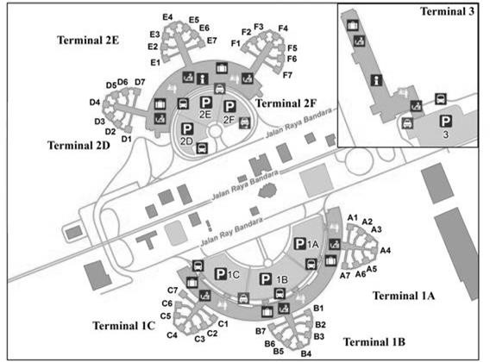

***Figure 2. Soekarno-Hatta International Airport (CGK) - Overview***

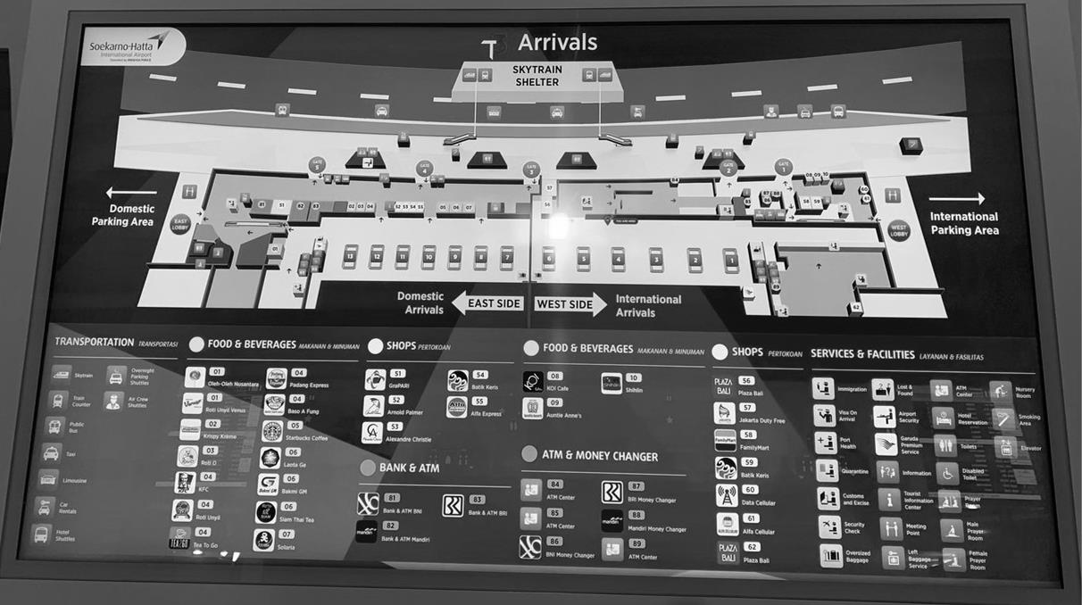

***Figure 3. Terminal Map Information Board***

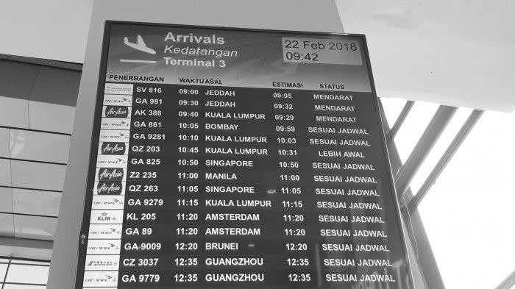

## Lost and Found Staff

***Figure 4. Flight Schedule Information Board***

Lost and Found Staff **manage the operations of the lost and found department**, assisting passengers who have misplaced personal items within the airport. In the LinKasa application, they can **create, view, and update a digital log of lost and found items**, where the staff can **attach photos and descriptions** to each lost and found item entry, **facilitating quick retrieval of information**, **and assisting in returning items to their rightful owners more efficiently**. Furthermore, the application assists in **coordinating with other departments** to track down lost items, allowing staff to **update their status** as either “returned to owner” or “unclaimed”.

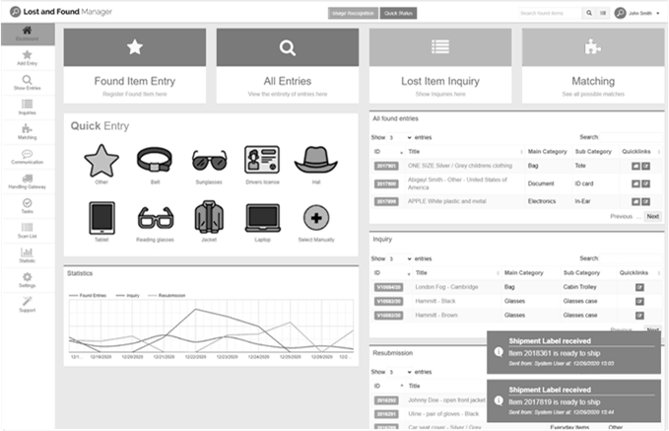

## Check-in Staff

***Figure 5. Example of Lost and Found Application Interface***

Check-in staff are responsible for **assisting passengers during the check-in process**, which includes **verifying tickets**, **checking luggage**, and **issuing boarding passes**. Utilizing the LinKasa application, they can streamline this process by accessing **real-time flight** and **passenger information** and **managing luggage or baggage more efficiently**. Specifically, the check-in staff can **upload photos** of luggage or baggage and/or **manually input** data such as **weight, dimensions, contents of the luggage, etc**. Additionally, they can **quickly communicate** with other departments in case of any issues or requests for special assistance. Moreover, the application aids in the seamless **creation and modification of boarding passes**, accommodating all necessary passenger information within the system. Moreover, check-in staff can **print out a boarding pass** as a **detail view** consist of all the **detail** of the boarding pass. In case of alterations in travel plans, check-in staff **have the discretion to cancel or update boarding passes** as needed, allowing for flexible adjustments to passenger itineraries or journeys without causing delays or disruptions.

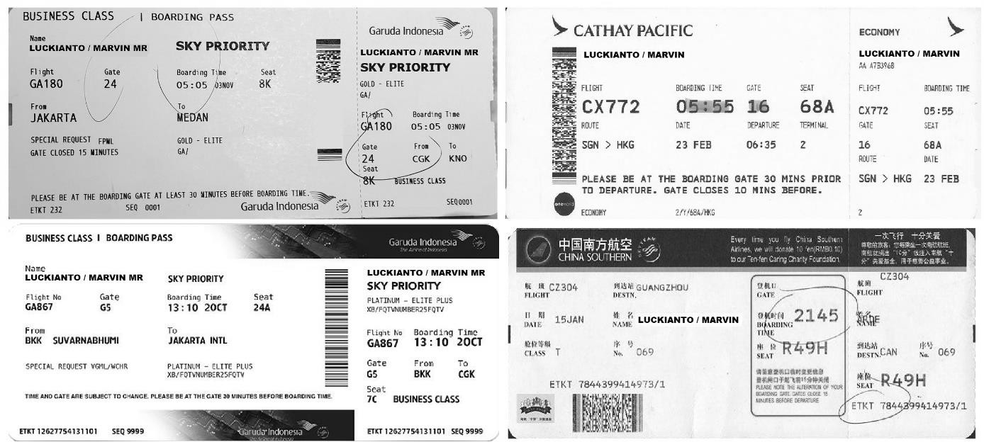

## Gate Agents

***Figure 6. Example of a Boarding Pass and Its Details***

Gate Agents are responsible for **managing the boarding process** at the **flight gates**. Their duties include **assisting passengers** with boarding, **managing seating arrangements**, and **addressing any last-minute ticketing concerns**. Utilizing the LinKasa application, they **can streamline the boarding process** by having **real-time access to flight information**, **seating charts**, and **passenger data**. This system facilitates quicker resolution of ticketing issues by providing timely updates on situations such as flight delays, directly informing gate agents to make necessary adjustments. Moreover, in cases of gate changes, the information is promptly relayed to the gate agents, ensuring smooth boarding operations. In emergencies, the LinKasa app’s **chat feature** enables **public messaging**, allowing individuals in every role within the airport to view the chat messages.

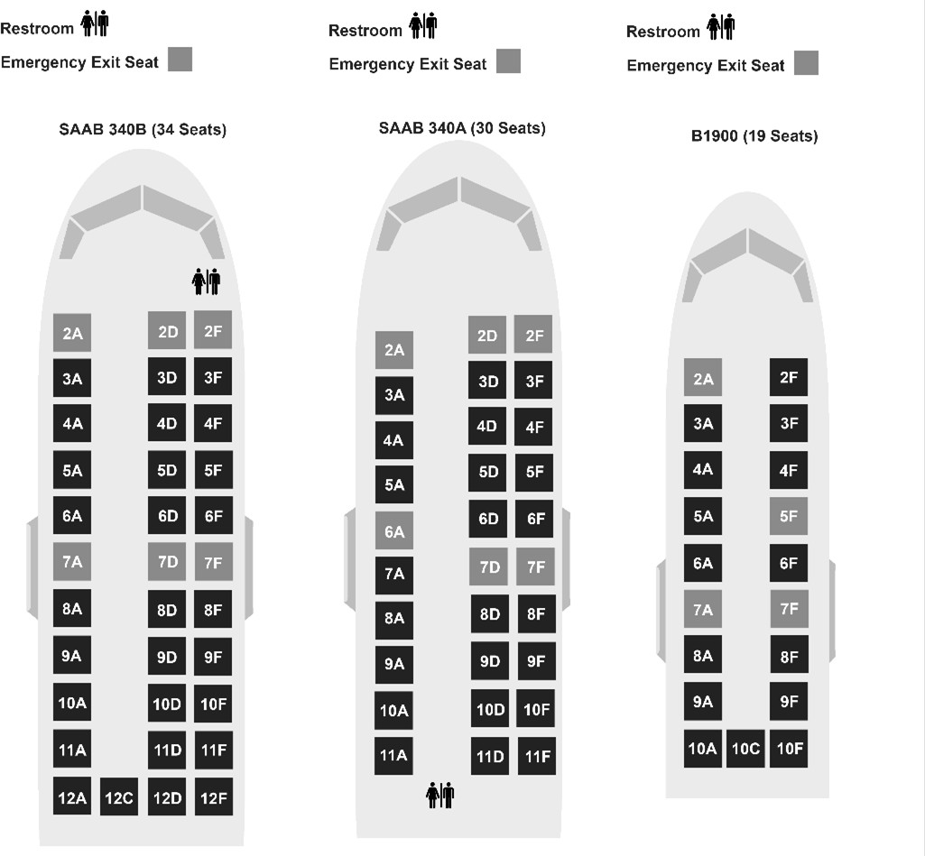

***Figure 7. Aircraft Seating Chart***

**Operations and Coordination**

## Airport Operations Manager

The Airport Operations Manager **oversees the entire operations of the airport**, ensuring that all components, including terminals, runways, and support services, operate harmoniously. This role involves problem-solving, strategy implementation, and coordination among various departments. Using the LinKasa application, they can utilize a **comprehensive dashboard to monitor daily operations**. This includes **access to real-time flight information**, such as **scheduled flights** and **current flight statuses**. It also **provides updates on baggage handling operations**, including loading, unloading, and transfers. Furthermore, the manager can **monitor and manage maintenance requests for airport facilities and equipment** and **receive live updates on the current weather conditions** at the airport. Additionally, they can **coordinate between different departments** to ensure seamless operation. In the case of emergencies, they can respond swiftly by rallying the necessary teams and resources through the **chat feature** within the LinKasa application. These chat messages **can be viewed by individuals in every role within the airport**, facilitating timely and efficient communication.

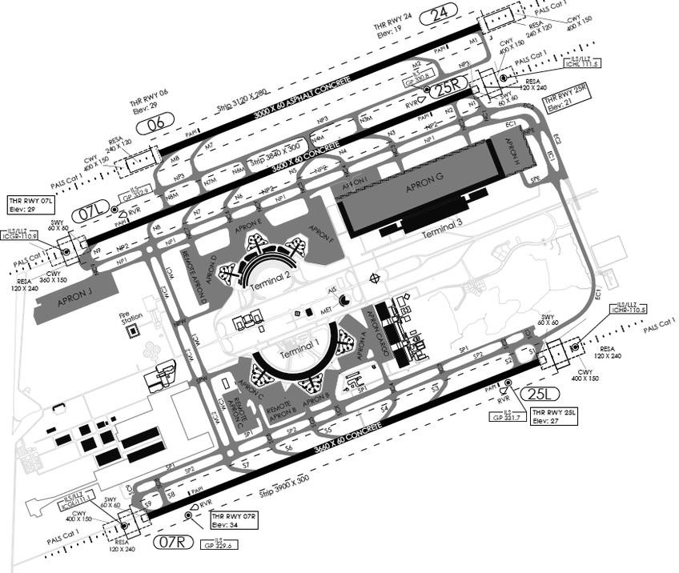

***Figure 8. Layout of Soekarno-Hatta International Airport***

## Flight Operations Manager

The Flight Operations Manager **supervises the scheduling, planning, and management of flights within the airport**. They ensure the timely arrival and departure of flights while coordinating with ground services and air traffic control. To aid in their duties, they can leverage the capabilities of the LinKasa application. This tool allows them to closely monitor **real-time flight data**, which includes **crucial information** such as airplane **numbers or IDs**, **boarding times**, **arrival times**, and **points of origin and destination**. They can also track flight statuses which are categorized as **“delayed”**, **“arrived”, “in-transit”, “cancelled”, etc**. Furthermore, they can efficiently **manage flight schedules** and **keenly monitor any delays or cancellations**, thus enabling them to act swiftly in implementing necessary adjustments. The application also grants them access to **detailed information regarding the total number of passengers**, their **personal details**, and the **particulars of pilot crews for each flight**. Flight Operations Manager may **manage and assign flight crews**,

including **pilots and cabin crew**, **to specific flights**. Additionally, to facilitate smooth operations and real-time updates, they can communicate any adjustments or delays to the relevant parties through the integrated **chat feature** within the LinKasa application. This ensures seamless communication and coordination among various stakeholders, fostering a more efficient and responsive airport environment.

## Ground Handling Manager

The Ground Handling Manager **oversees the activities related to aircraft handling at the ground level**, which includes **baggage handling, aircraft cleaning**, **and refueling**. The status of baggage claim may refer to various stages such as **“received for transport”**, **“in transit”**, **“ready for pick- up”**, or **“claimed by passenger”**. Using LinKasa, they can monitor these **statuses in real-time**, ensuring **bags are promptly moved through each stage**. Additionally, they can oversee, and **manage refueling schedules**, and ensure the **timely availability of ground handling staff by scheduling their tasks**, promoting efficient operations and passenger satisfaction. Once tasks are assigned by the Ground Handling Manager, the respective staff will be **notified**. In emergencies, the LinKasa app’s **chat feature** allows quick coordination by letting everyone at the airport view messages, making communication fast and efficient.

## Landside Operations Manager

The Landside Operations Manager is **entrusted with the critical responsibility** of overseeing the airport’s **landside domains**, which **encompass parking facilities, ground transportation services, and terminal access**. They aim to streamline transportation flows and enhance passenger convenience. Using the LinKasa application, they could **manage transportation schedules and routes**, then they could oversee **parking facilities** to optimize traffic flow and improve transportation services. Through the application, they can offer **detailed information on transportation routes** and **manage the landside operations staff to manage each segment of the journey**. This data is essential in optimizing one-way deliveries, gaining insights into the transported cargo, and pinpointing the individuals responsible for transportation at different stages. In emergencies, the LinKasa app’s **chat feature** allows quick coordination by letting everyone at the airport view messages, making communication fast and efficient.

## Maintenance Manager

The Maintenance Manager **oversees ensuring that all airport facilities and equipment are well- maintained and operational**. This includes preventative maintenance and repairs to maintain safety and operational efficiency. Within the LinKasa system, they could **manage maintenance schedules**, **track equipment statuses** which are categorized as **“fully operational”, “scheduled maintenance”, “under maintenance”, etc.,** assign specific maintenance tasks to appropriate

personnel based on equipment needs, and coordinate with **maintenance personnel** using the **chat feature** within the LinKasa application to ensure that all facilities and equipment are maintained in optimal condition. The various types of equipment can be categorized as follows:

## Ground Support Equipment

* 1. Aircraft tow tractors
  2. Baggage conveyors
  3. Belt loaders
  4. Ground power units
  5. Air start units
  6. Fuel trucks
  7. De-icing vehicles

## Terminal Equipment

* 1. Escalators and elevators
  2. Moving walkways
  3. Baggage carousel systems
  4. Security screening equipment (X-ray machines, metal detectors)
  5. Air conditioning and heating systems
  6. Information displays and PA systems.

## Runway and Taxiway Equipment

* 1. Runway lighting systems
  2. Taxiway lighting systems
  3. Windsocks and weather monitoring equipment
  4. Ground radar systems

## Aircraft Maintenance Equipment

* 1. Hydraulic jacks and lifts
  2. Ground support equipment tooling
  3. Maintenance platforms and dockings
  4. Aircraft ladders and stairs

**Security and Safety**

## Customs and Border Control Officers

The Customs and Border Control officers are **responsible for monitoring and controlling the movement of people and goods across the country’s borders**. They ensure compliance with customs and immigration laws, check passports, visas, and handle customs declarations. To streamline these processes, officers utilize the LinKasa application. This enables swift and efficient handling of passenger information and immigration procedures. Officers can manually **input passport and visa details**, whereas passengers can **choose to submit customs declarations electronically**, a process that entails the submission of personal details and travel documents. When passengers elect to utilize this feature, they are required to **enter a range of information**. This generally includes personal details such as their **full name**, **nationality**, and **date of birth.** They must also provide specific details relating to their travel documents, including **passport number** and **visa details** (if applicable), as well as information regarding their flight or vessel. If there is any incorrect or outdated information, either the passenger or the officer may **remove the passport and visa details** from the system. Officers may also **modify submitted details** based on further inspections and **remove outdated or incorrect customs declarations** from the system. Furthermore, passengers

may be asked to supply their **travel itinerary** and the **purpose of their visit**. Beyond data entry, the **Customs and Border Control Officer** can **generate** a **detailed view** of all the passenger data that already inputted. the LinKasa application serves as a **real-time tracking system**, meticulously **logging details** such as the **time, date, and location of border crossings, and closely monitoring the movement of both individuals and goods**. Additionally, the application assists in **creating inspection record document of detailed inspection record of goods, encompassing photographs, descriptions, and notes on any irregularities observed**. Officers may also **modify inspection records** based on further investigations and **remove completed or outdated inspection records** from the system. The application could also **facilitate the generation of reports** on passenger and goods movement, swiftly identifying and flagging any irregularities or potential security threats. In emergencies, the LinKasa app’s **chat feature** allows quick coordination by letting everyone at the airport view messages, making communication fast and efficient.

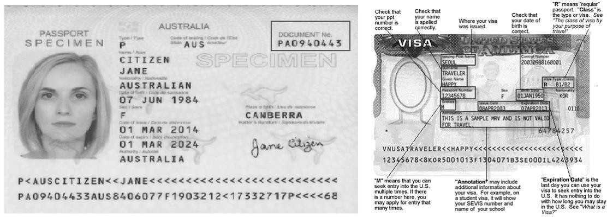

***Figure 9. Example of a Passport and Visa Details***

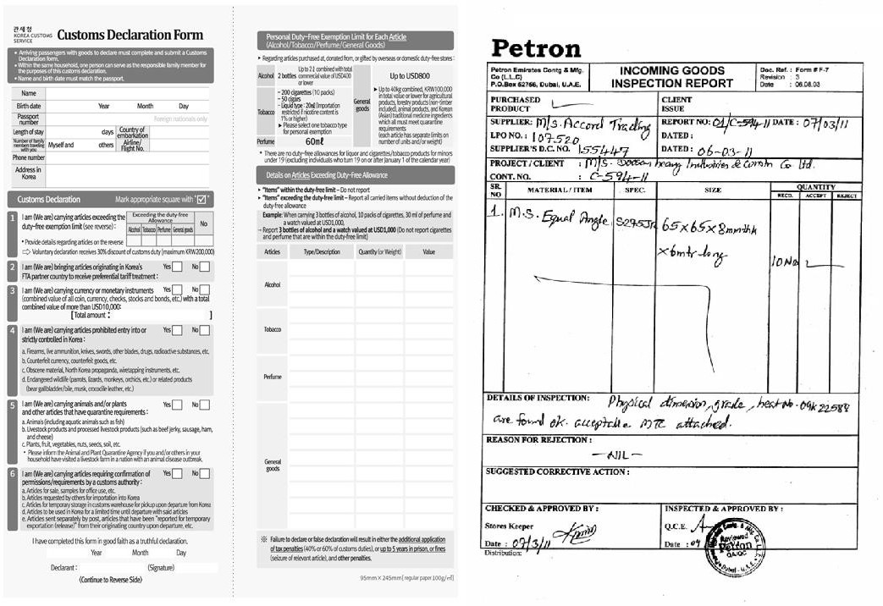

***Figure 10. Examples of a Customs Declaration Form (Left) and an Inspection Records Report (Right)***

## Baggage Security Supervisor

The Baggage Security Supervisor **oversees ensuring the security of passenger luggage from the moment it is checked in until it reaches its destination**. This role encompasses overseeing the baggage screening processes to prevent the transportation of prohibited items and securing the areas where baggage is handled. Utilizing the LinKasa application, the Supervisor can **effectively monitor real-time baggage statuses**, **manage baggage status, manage the deployment of staff in baggage handling areas**, and **manage a log of any security incidents pertaining to baggage**. They are also equipped to **trace unidentified items** (the data will appear in the **lost and found department**) and **generate reports on the security operations concerning baggage (bagus buat bikin subsystem soalnya dipake di controls officer juga)**. The attributes and statuses they need to keep a close eye on include the current status of the baggage **“checked”, “loading”, “transfer”, “in transit”, “unloading”, “received” or “delayed”** details of any security incidents such as the discovery of prohibited items or cases of lost, the personnel involved including the names of the officers responsible and their zones of responsibility, and daily activity reports that encapsulate **details of incidents, response times, and actions taken**. Moreover, the application assists in analyzing trends over time through periodic reports, and aids in baggage identification through unique identification numbers, as well as weight and dimension details. In emergencies, the LinKasa app’s **chat feature** allows quick coordination by letting everyone at the airport view messages, making communication fast and efficient.

**Checked** : Baggage is checked in by the passenger at the airline’s check-in counter.

**Loading** : Baggage is loaded onto the aircraft before departure.

**Transfer** : Baggage is transferred from one flight to another during a layover or connection.

**In transit** : Baggage is in transit when it's being moved between flights, usually during a connecting journey.

**Unloading** : Baggage is unloaded from the aircraft after landing and is on its way to the baggage claim area.

**Received** : Baggage is received at its destination airport and is ready for further processing.

**Delayed** : Baggage is marked as “delayed” when it doesn’t arrive at its intended destination on time, and there is a delay in its delivery to the passenger.

**Logistics, Cargo, and Supply Chain**

## Cargo Manager

The Cargo Manager **oversees the transportation and handling of cargo at the airport**. They are responsible for ensuring the safe, timely, and efficient processing of cargo shipments, including managing cargo storage facilities, overseeing freight operations, and liaising with customs and other relevant authorities. In the LinKasa application, the Cargo Manager has the capability to **monitor cargo shipments in real-time**, **tracking their current status** and **historical movement**—which includes classifications such as **“awaiting pickup”, “in transit”, “under inspection”, “stored”, “delayed”, “delivered”, “damaged”, “lost”, and “pending customs”**—and **pinpointing their exact location**. Additionally, it facilitates seamless **management of storage space allocations** by **displaying real-time availability** and allows for efficient **coordination with ground handling teams, including cargo handlers and customs teams** through its integrated **chat features**. Furthermore, the Cargo Manager has the authority to **manage cargo handling tasks**.

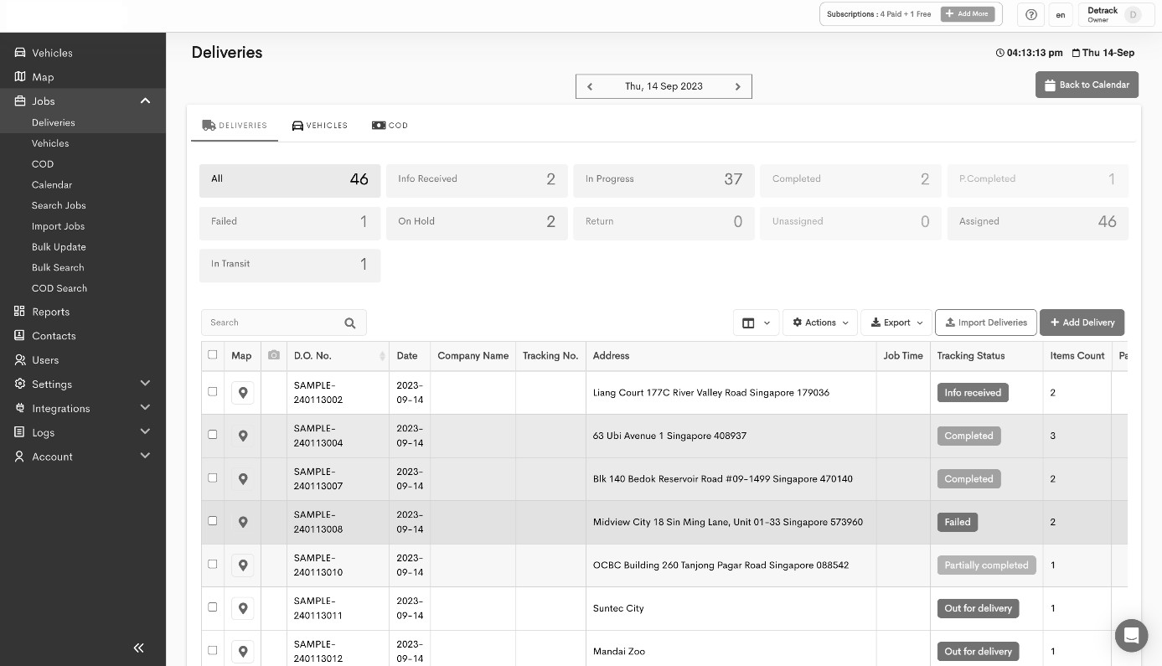

***Figure 11. Example of Cargo Shipment Tracking Application Interface***

## Logistics Manager

The Logistics Manager handles the **flow of goods and materials throughout the airport**. They are tasked with **planning, implementing, and controlling procedures** to effectively manage the logistics chain from receiving to distribution. Using the LinKasa application, the Logistics Manager can **oversee the entire logistics chain**. This allows the manager to **generate detailed reports concerning all logistics processes, including but not limited to inventory levels, and cargo movement stages distribution type**. The logistic manager also can handle the **logistics distribution type** and track the **stages or routes of cargo movements**. The application facilitates **real-time** tracking of **shipments** and **deliveries**, including their **current status and location**, **and assists** in **proficiently managing inventory levels**. It categorizes logistics into internal and external segments, providing options to determine the desired transfer points and designate individuals responsible for the shipments. Moreover, it enables seamless **coordination with various departments** to ensure efficient logistics operations, utilizing the **chat feature** within the LinKasa application for easy communication. Additionally, the application aids in optimizing routes for internal transportation and fostering strong supplier relationships. For instance, in managing supplier relationships, the logistics manager can create a comprehensive list of supplier data. This facilitates regular communication, allowing the manager to maintain robust relationships with external parties through the chat functionality in the LinKasa application.

* **Internal logistics**: This refers to the movement and management of goods within the airport. This might include handling the supply of materials required for airport maintenance, food and beverage supplies for airport restaurants, duty-free goods for retail outlets, etc. The Logistics Manager ensures the seamless operation of this internal supply chain, overseeing the storage, distribution, and inventory management of goods to meet the airport’s operational needs.
* **External logistics**: This involves overseeing the logistics pertaining to goods that are transported to and from the airport, including cargo handling services. The Logistics Manager might be involved in overseeing the logistics of goods being shipped through the airport, including the handling of cargo shipments, managing cargo storage facilities, and coordinating with customs and border control agencies.

## Fuel Manager

The Fuel Manager is responsible for **managing the fuel supply chain at an airport**. This includes **overseeing fuel storage facilities**, ensuring compliance with safety and environmental regulations, and coordinating with airlines and fuel suppliers for aircraft refueling. In the LinKasa application, the Fuel Manager can **manage fuel inventories** (real-time data on current fuel levels in storage facilities), **manage schedule fuel deliveries, including information on the staff handling the task and the quantity of fuel being delivered**, **Features** to **log** and **track fuel deliveries** including information on **quantity** and **supplier details**, and **track fuel consumption patterns**, viewing patterns by hours. This application **facilitates real-time monitoring of fueling operations** and helps ensure compliance with safety and environmental standards.

## Cargo Handlers

Cargo Handlers are **responsible for the physical handling of cargo at the airport**. They load and unload cargo from aircraft, transport cargo to and from storage areas, and ensure the safe handling of goods. Using the LinKasa application, cargo handlers can **receive step-by-step instructions** for handling cargo, including **real-time task assignments** that detail which cargo to handle, the specific aircraft or storage location, and handling instructions and **report the status of cargo movements**. The application aids the cargo handler in **inputting the status of cargo movements**, such as “loading”, “transiting”, “storing”, or “unloading”. The system can help in assigning tasks efficiently and ensuring adherence to handling guidelines to prevent damage or loss. In emergencies, the LinKasa app’s **chat feature** allows quick coordination by letting everyone at the airport view messages, making communication fast and efficient.

**Engineering and Maintenance**

## Civil Engineering Manager

The Civil Engineering Manager **oversees the structural integrity of the airport’s infrastructure**, including runways, terminals, and other facilities. They are **responsible for planning and implementing construction and renovation projects** to ensure the airport’s physical structures meet safety and efficiency standards. Within the LinKasa application, they could **access and manage project plans**, **monitor the progress of ongoing construction or renovation works**, and ensure adherence to safety and quality standards. They could also use the system to **coordinate with other departments** and **manage budgets and resources efficiently (BELOM ADA)**. It is important to highlight that all **budget requests** require **approval from the Chief Financial Officer (CFO)**. The system **does not** permit **updates** to existing budget amounts; therefore, one **must delete** the **current entry** and **create a new one.** Additionally, deletions are only allowed if the CFO has not already approved the entry.

**Executive Level**

## Airport Director/CEO

The Airport Director or CEO stands at the helm of the organization, **overseeing all aspects of the airport’s operation and management**. They are responsible for the development and execution of strategic plans, ensuring that the airport meets its goals and maintains a high standard of safety and efficiency. In the LinKasa application, they have **access to a dashboard where they can view comprehensive reports** and **analytics concerning various departments and functions within the airport**. For instance, the CEO can **visualize comprehensive reports** in various formats such as line charts, which can be utilized to **track revenue and expenses either collectively or for specific**

**departments**. Furthermore, they can **download financial reports** through the LinKasa application, with the **reports** being **deliverable in CSV/XLSX format**.

## Chief Financial Officer (CFO)

The CFO oversees **managing the financial operations and strategies of the airport**. This includes budget management, financial planning, and oversight of financial procedures and controls. Within the LinKasa application, the CFO can **access tools designed for financial planning and budgeting**, **tracking** and **manage revenue and expenses in real time**, and **generating detailed financial reports**, which provide insights into revenue, expenses, budget plans, and other aspects relevant to the financial department’s responsibilities. They could also **monitor the financial performance of different departments and projects**, helping to ensure that the airport operates within its budget and meets its financial goals. Furthermore, the CFO plays a crucial role in **overseeing financial fund requests initiated by other departments**. CFO has the **authority to review, accept, reject, or revise** these **requests** based on a thorough evaluation of the financial implications and alignment with the airport’s budget and strategic objectives. This function within the LinKasa application acts as a centralized platform where the CFO can manage fund requests efficiently, ensuring optimal allocation of resources and fostering financial prudence across all departments.

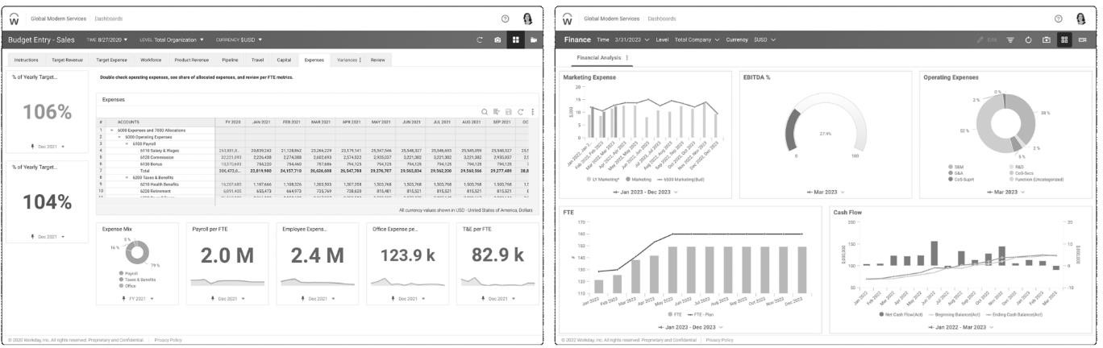

***Figure 12. Financial Planning and Budgeting Application Interface***

## Chief Operations Officer (COO)

The COO is **responsible for the daily operations of the airport**, ensuring that all operations run smoothly and efficiently. They oversee a range of departments including maintenance, ground support, and flight operations. Leveraging the capabilities of the LinKasa application, they can enhance their oversight in various facets of the airport’s functioning. Firstly, the application **facilitates meticulous scheduling and real-time monitoring of flights**, empowering the COO to guarantee timely departures and arrivals while mitigating potential disruptions. Furthermore, LinKasa provides the COO with **comprehensive insights into managing facility management** they can **manage details** about the **newly constructed** or **added infrastructure**. This encompasses various

aspects, such as **physical infrastructure and utility management**. Speaking of physical infrastructure, the airport is equipped with a range of facilities including runways, taxiways, terminals, hangars, and parking and cargo facilities, as well as ground support and vehicle fleet equipment. On the utility management front, particular attention is devoted to energy and water management. Specifically, for energy and water management, the LinKasa application can **generate detailed statistics on the consumption of both energy and water**. From this data, it becomes possible to **create daily reports** to analyze monthly usage and trends, assisting in efficient resource management. As for physical infrastructure, LinKasa can provide information in the form of easy-to- view cards. These cards can display essential data, such as the number of available vehicle fleet units or equipment, in comparison to the total quantity. Such transparency allows the COO to swiftly allocate resources, ensuring that both ground support and vehicle fleet equipment are optimally utilized. Furthermore, this data can guide the **scheduling of regular maintenance checks**, allowing for **real-time viewing of ongoing maintenance activities and managing maintenance schedules**. Details such as the type of maintenance (routine, preventive, or emergency), the description of the task, and the expected time to completion can be accessed to address emerging issues promptly and further safeguarding the airport infrastructure’s peak performance. In emergencies, the LinKasa app’s **chat feature** allows quick coordination by letting everyone at the airport view messages, making communication fast and efficient.

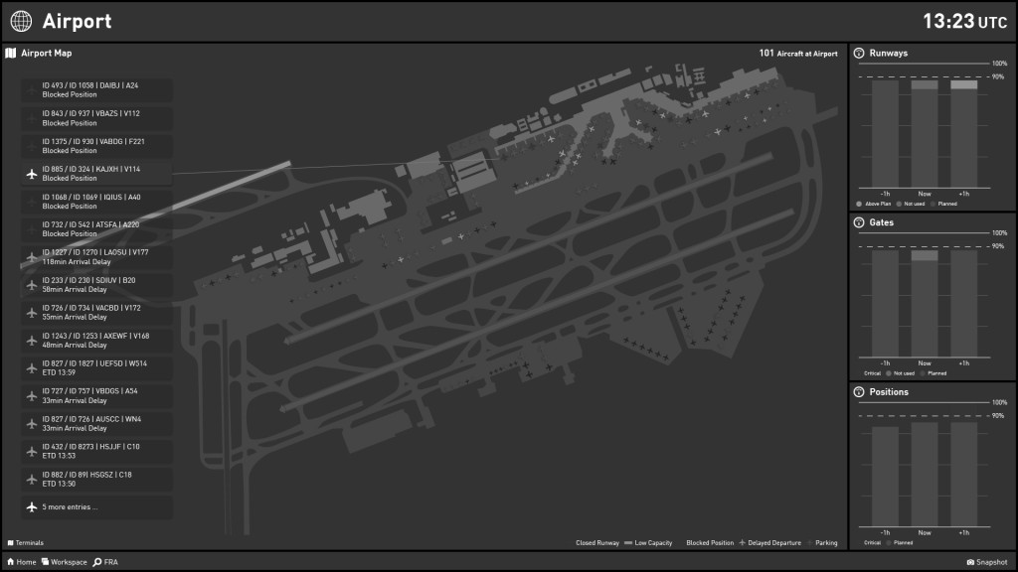

***Figure 13. Example of Chief Operation Officer (COO) Dashboard Application Interface***

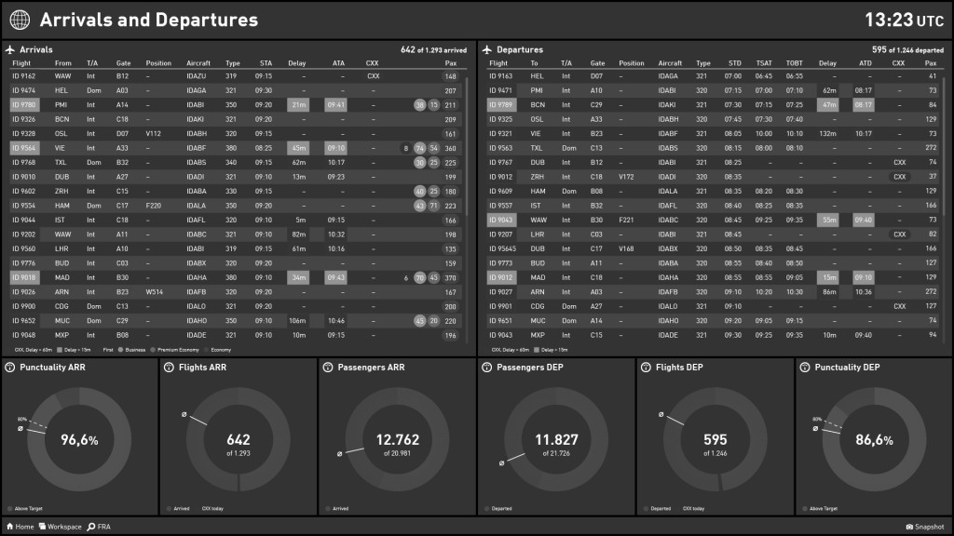

***Figure 14. Example of Chief Operation Officer (COO) Dashboard Application Interface (Arrivals and Departures Section)***

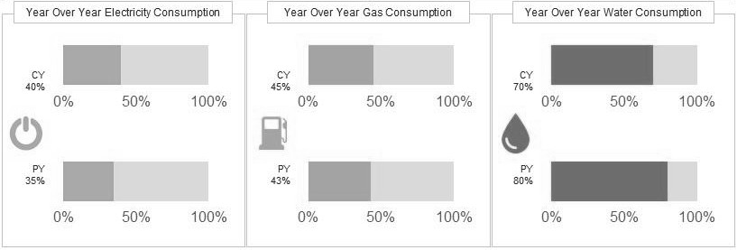

***Figure 15. Example of Energy and Water Statistics Application Interface***

## Chief Security Officer (CSO)

The CSO is responsible for **overseeing the security infrastructure of the airport**. This includes implementing security policies, overseeing security personnel, and ensuring the safety of passengers and staff. In the LinKasa application, the CSO could **monitor and manage security incidents** and **managing the training, deployment, and scheduling of security personnel**. They might also use the application to **coordinate with various departments** to receive notifications regarding potential threats or incidents. Furthermore, the CSO is responsible for **generating detailed security reports** that encapsulate a wide range of data points. These data points may include **incident statistics, response times**, and **comprehensive performance metrics** of the security personnel, such as the **total number of cases** handled by each team member.

## Human Resources Director

The Human Resources Director **oversees all aspects of human resource management**, **encompassing recruitment, training, and employee relations**. Through the LinKasa application, the HR Director can streamline the **recruitment process by taking various steps**, such as **managing job vacancies**. The details required for posting include the **job position**, **job description** or **information**, location, etc. Additionally, they can facilitate the **acceptance of job offers** in **real- time**. Additionally, they can **arrange and manage employee training and development programs**.s The application also **allows for the management of employee records and information** such as **Modify or update employee records as needed**, **remove records of employees who have left the organization,** and **view detailed employee data** including performance and **training histories**. It should be noted that the Human Resources Director can **create staff data** based on the given role criteria:

* 1. Customer Service Manager
  2. Information Desk Staff
  3. Lost and Found Staff
  4. Check-in Staff
  5. Gate Agents
  6. Air Operations Manager
  7. Flight Operations Manger
  8. Ground Handling Manager
  9. Ground Handling Staff
  10. Landside Operations Manager
  11. Maintenance Manager
  12. Maintenance Staff
  13. Customs and Border Control Officers
  14. Baggage Security Supervisor
  15. Baggage Security Staff
  16. Cargo Manager
  17. Logistic Manager
  18. Fuel Manager
  19. Cargo Handlers
  20. Civil Engineering Manager
  21. Airport Director/CEO
  22. Chief Financial Officer (CFO)
  23. Chief Operations Officer (COO)
  24. Chief Security Officer (CSO)

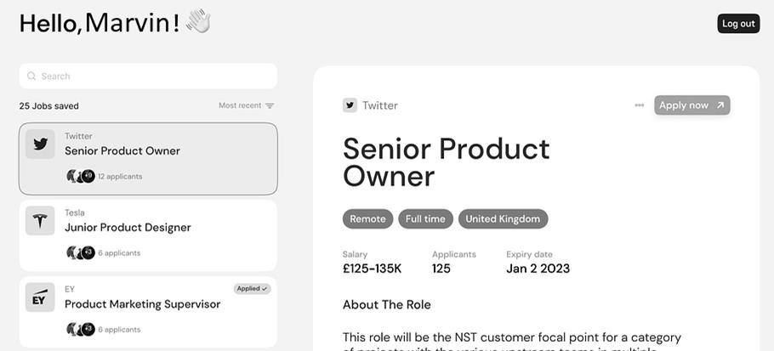

***Figure 16. Example of Job Seeking Application Interface***

**Note:**

1. Each **role** mentioned above may have its own staff, except the executive level. Therefore, it’s crucial to **ensure** that the desktop application **allows you to create, update or modify, view, and delete** the respective data accordingly.
2. All **data** or **information**, such as refueling schedules, staff schedules, maintenance tasks, baggage statuses, transportation routes, financial entries, incident log, etc., needs to be provided in the application. It’s essential to ensure that the respective roles have the **capabilities to create, update or modify, view, and delete** the respective data accordingly.
3. The desktop application should **authenticate** the current user and **authorize** actions based on the data of the logged-in user.

|  |  |  |
| --- | --- | --- |
| IndonesiaTimes.com  Jl. Raya Kb. Jeruk No.27, RT.1/RW.9, Kb. Jeruk, Kec. Kb. Jeruk, Kota Jakarta Barat, Daerah Khusus Ibukota Jakarta 11530 |  | VOL. II NO. 32  JAKARTA, WEDNESDAY, SEPTEMBER 7TH, 2023 |

# LinKasa Operations Enhancement: A Comprehensive Desktop Application for Advanced Airport Management System

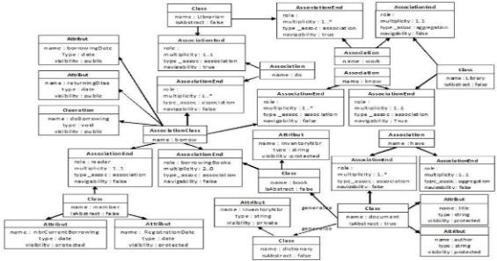You, as a system analyst, are assigned by the manager of LinKasa to **develop a software program** based on the details mentioned earlier, following the principles laid out in **System Analysis and Design in a Changing World Edition 7e**1. Utilizing **Visual Paradigm Community Edition 17.1** or a newer version, you are expected to create the following components:

1. 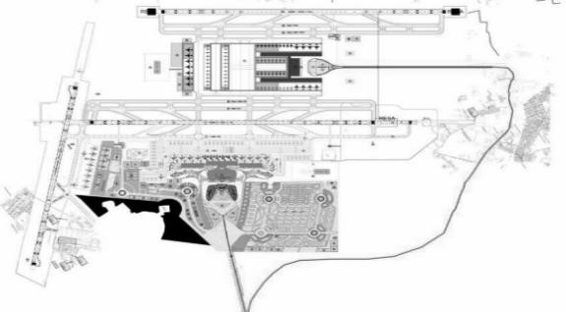**Use Case Diagram**
2. Seven (7) Unique **Full Use Case Descriptions**
3. Seven (7) Unique **Activity Diagrams**
4. Seven (7) Unique **Multi-layer Sequence Diagrams** with Fragment(s)
5. **Updated Class Diagram** with Relationships

Considering the constraint on the number of detailed use case descriptions, activity, and multi-layer sequence diagrams, you are **mandated** to opt for **use cases** that are **grounded in complex logic**, as opposed to simpler ones. You are allowed to make assumptions about the program’s design, but it must be logical, and you must be able to explain all the created diagrams.

**Execute the previously devised program’s design** into a functional internal system to be utilized by LinKasa. The development of the program permits the use of any front-end technology, provided that it is assembled as a desktop application employing **Electron 26.1.0 (or a more recent version)** and integrates **Firebase** as its backend and database solution. To ensure the code is streamlined, it is mandatory to include at least **three design patterns** applied correctly within the program. Given that the program will be accessed by a considerable number of employees across various age groups, it should be constructed to **mitigate or minimize human errors** and offer a **positive and good user experience**. The program should also include a **timestamp** and **soft deletion** mechanism to quickly identify and rectify data discrepancies. Additionally, **provide at minimum four (4) shortcut keys**, **four (4) tray menu items**, and **a unique app icon**.



**Wonderful things can be achieved when there is teamwork, hard work, and perseverance.**

**Bluejackets 22-2** ◆:v ’x

1 Satzinger J. W. Jackson R. B. & Burd S. D. (2016). Systems Analysis and Design in a Changing World (7eth ed.). Thomson Course Technology